SUCHETA NAIK

182000492

Business Forecasting: Assignment 3

Kindly select dataset with time-series data

1) Plot the datasets to see how it looks. What can we tell from these?

2) Check if there exists a seasonality or trend using plot and state your results with valid reasons

3) Plot Autocorrelation graph and see if there exists seasonality or trend and explain the results

**Introduction:**

The data used in this example is nottem which is standard time series dataset available in R.

The nottem dataset is the average air temperatures at Nottingham Castle in degrees Fahrenheit, collected for 20 years, on monthly basis.

1. **Plot the datasets to see how it looks. What can we tell from these?**

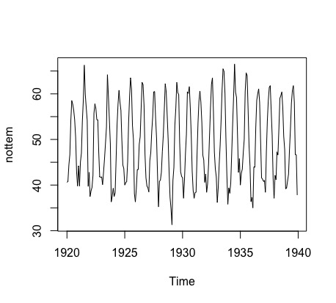

From this plot, we can deduce that there exists seasonality in the data. In a period of 5 years the average temperature tends to increase and decrease during the same time period. From the plot, it can be concluded that the average temperature rises during the months of May to August and gradually starts falling. The average temperature drops during the months of November to February and gradually starts increasing.

**From the plot, it can be inferred that the model is an additive component model because seasonal variation is relatively constant over time.**

**.**

**../../Screen%20Shot%202018-02-06%20at%204.57.07%20PM.png**

Observing the plot deduces that the data is seasonal and is distributed in the range of 31 to 67 degrees Fahrenheit. The dataset has a minimum value of 31.30, the 1st Quartile's value is at 41.55, the median's value is 47.35, the mean’s value is 49.04, the 3rd Quartile's value is 57 and a maximum value of 66.50.

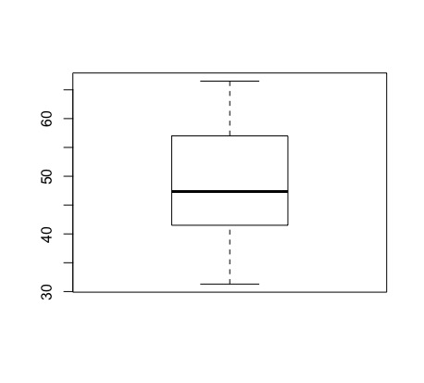

* From the Boxplot, we can deduce that it is short which implies that the average temperature has high agreement.
* The longer upper whisker and the lower whisker means that the average temperature is varied among the most positive quartile values.
* There is no outlier hence our observation is normally distributed.

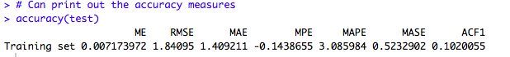

Mean error (ME) is 0.007173972,

Root mean squared error (RMSE) is 1.84094

Mean absolute error (MAE) is 1.409211

Mean percentage error (MPE) is -0.1438655

Mean absolute percentage error (MAPE) is 3.085984

Mean absolute scaled error (MASE) is 0.5235902

First-order autocorrelation coefficient (ACF1) is 0.1020055

1. **Check if there exists a seasonality or trend using plot and state your results with valid reason**

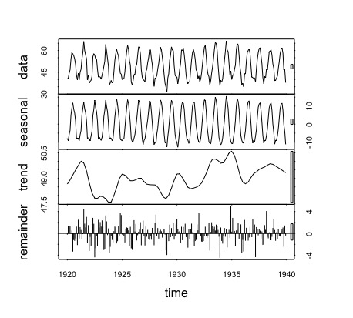

* The four graphs are the original data, seasonal component, trend component and the remainder and this shows the periodic seasonal pattern extracted out from the original data and the trend that moves around between 47 and 51 degrees Fahrenheit.
* There is a bar at the right-hand side of each graph to allow a relative comparison of the magnitudes of each component.
* For this data, the change in trend is less than the variation doing to the monthly variation.
* Within a given year the maximum of the series occurs in the summer and the minimum in the winter.

**Since, the maximum temperature is in the summer, so the “seasonality” of the temperature series is expected.**

**3) Plot Autocorrelation graph and see if there exists seasonality or trend and explain the results**

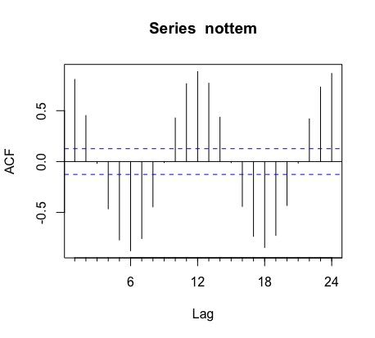

* The ACF plot tends to decay exponentially indicating stationary series presence. Most of the ACF plot values also remain inside the significance range (Blue-dotted range).
* The stationarity clause implies that the series is going either up or down overtime.
* The peak is observed in the 12th and 24th instances in the graph indicating a repetitive pattern indicating seasonality.
* The peak occurs at the lag of 12 months because May 1920 correlates with May of 1921 and May 1922.
* The troughs also exhibit the same pattern i.e. 12 months apart.

**Hence exhibiting Seasonality.**